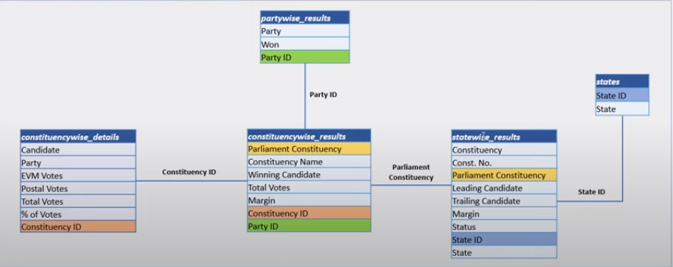

1. **Total Seats**

select

Distinct count(Parliament_Constituency) as [Total Seats]

from constituencywise_results



1. **What is the total number of seats available for elections in each state**

Select s.State, count(Distinct Parliament_Constituency) as [Total Seats Statewise]

from statewise_results sr

join states s on sr.State_ID = s.State_ID

group by s.State

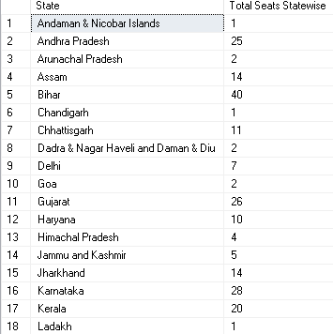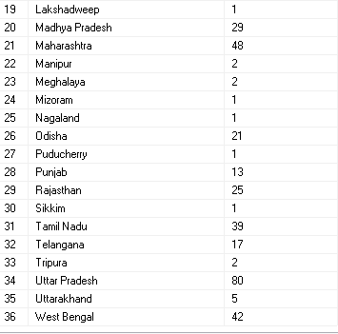

1. **Total Seats Won by NDA Allianz**

select

sum (

case when party in (

'Bharatiya Janata Party - BJP',

'Telugu Desam - TDP',

'Janata Dal (United) - JD(U)',

'Shiv Sena - SHS',

'AJSU Party - AJSUP',

'Apna Dal (Soneylal) - ADAL',

'Asom Gana Parishad - AGP',

'Hindustani Awam Morcha (Secular) - HAMS',

'Janasena Party - JnP',

'Janata Dal (Secular) - JD(S)',

'Lok Janshakti Party(Ram Vilas) - LJPRV',

'Nationalist Congress Party - NCP',

'Rashtriya Lok Dal - RLD',

'Sikkim Krantikari Morcha - SKM'

)

Then [Won]

Else 0

END)as [Total Seats Won by NDA]

From partywise_results;



1. **Seats Won by NDA Allianz Parties**

Select Party as [Party Name], Won as [Total Seats Won]

from partywise_results

where party in (

'Bharatiya Janata Party - BJP',

'Telugu Desam - TDP',

'Janata Dal (United) - JD(U)',

'Shiv Sena - SHS',

'AJSU Party - AJSUP',

'Apna Dal (Soneylal) - ADAL',

'Asom Gana Parishad - AGP',

'Hindustani Awam Morcha (Secular) - HAMS',

'Janasena Party - JnP',

'Janata Dal (Secular) - JD(S)',

'Lok Janshakti Party(Ram Vilas) - LJPRV',

'Nationalist Congress Party - NCP',

'Rashtriya Lok Dal - RLD',

'Sikkim Krantikari Morcha - SKM')

order by Won Desc;

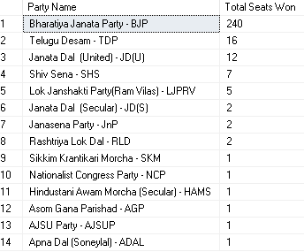

1. **Total Seats Won by I.N.D.I.A. Allianz**

select

sum (

Case when party in (

'Indian National Congress - INC',

'Aam Aadmi Party - AAAP',

'All India Trinamool Congress - AITC',

'Bharat Adivasi Party - BHRTADVSIP',

'Communist Party of India (Marxist) - CPI(M)',

'Communist Party of India (Marxist-Leninist) (Liberation) - CPI(ML)(L)',

'Communist Party of India - CPI',

'Dravida Munnetra Kazhagam - DMK',

'Indian Union Muslim League - IUML',

'Nat`Jammu & Kashmir National Conference - JKN',

'Jharkhand Mukti Morcha - JMM',

'Jammu & Kashmir National Conference - JKN',

'Kerala Congress - KEC',

'Marumalarchi Dravida Munnetra Kazhagam - MDMK',

'Nationalist Congress Party Sharadchandra Pawar - NCPSP',

'Rashtriya Janata Dal - RJD',

'Rashtriya Loktantrik Party - RLTP',

'Revolutionary Socialist Party - RSP',

'Samajwadi Party - SP',

'Shiv Sena (Uddhav Balasaheb Thackrey) - SHSUBT',

'Viduthalai Chiruthaigal Katchi - VCK')

Then [won]

Else 0

End

) AS [Total Seats Won by I.N.D.I.A Alliance]

from partywise_results;



1. **Seats Won by I.N.D.I.A. Allianz Parties**

select Party as [Party Name], Won as [Total Seats Won]

from partywise_results

where party in (

'Indian National Congress - INC',

'Aam Aadmi Party - AAAP',

'All India Trinamool Congress - AITC',

'Bharat Adivasi Party - BHRTADVSIP',

'Communist Party of India (Marxist) - CPI(M)',

'Communist Party of India (Marxist-Leninist) (Liberation) - CPI(ML)(L)',

'Communist Party of India - CPI',

'Dravida Munnetra Kazhagam - DMK',

'Indian Union Muslim League - IUML',

'Nat`Jammu & Kashmir National Conference - JKN',

'Jharkhand Mukti Morcha - JMM',

'Jammu & Kashmir National Conference - JKN',

'Kerala Congress - KEC',

'Marumalarchi Dravida Munnetra Kazhagam - MDMK',

'Nationalist Congress Party Sharadchandra Pawar - NCPSP',

'Rashtriya Janata Dal - RJD',

'Rashtriya Loktantrik Party - RLTP',

'Revolutionary Socialist Party - RSP',

'Samajwadi Party - SP',

'Shiv Sena (Uddhav Balasaheb Thackrey) - SHSUBT',

'Viduthalai Chiruthaigal Katchi - VCK')

Order by [Total Seats Won] Desc;

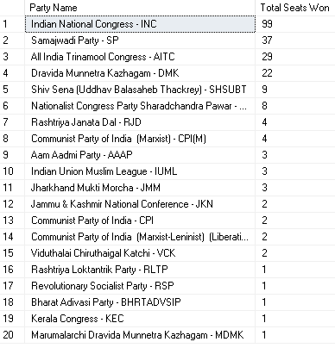

1. Add new column field in table partywise_results to get the Party Allianz as NDA, I.N.D.I.A and OTHER

alter table partywise_results

add party_allianz varchar(50);

update partywise_results

set party_allianz = 'NDA'

where party in

(

'Bharatiya Janata Party - BJP',

'Telugu Desam - TDP',

'Janata Dal (United) - JD(U)',

'Shiv Sena - SHS',

'AJSU Party - AJSUP',

'Apna Dal (Soneylal) - ADAL',

'Asom Gana Parishad - AGP',

'Hindustani Awam Morcha (Secular) - HAMS',

'Janasena Party - JnP',

'Janata Dal (Secular) - JD(S)',

'Lok Janshakti Party(Ram Vilas) - LJPRV',

'Nationalist Congress Party - NCP',

'Rashtriya Lok Dal - RLD',

'Sikkim Krantikari Morcha - SKM'

);

update partywise_results

set party_allianz = 'I.N.D.I.A'

where party in

(

'Indian National Congress - INC',

'Aam Aadmi Party - AAAP',

'All India Trinamool Congress - AITC',

'Bharat Adivasi Party - BHRTADVSIP',

'Communist Party of India (Marxist) - CPI(M)',

'Communist Party of India (Marxist-Leninist) (Liberation) - CPI(ML)(L)',

'Communist Party of India - CPI',

'Dravida Munnetra Kazhagam - DMK',

'Indian Union Muslim League - IUML',

'Jammu & Kashmir National Conference - JKN',

'Jharkhand Mukti Morcha - JMM',

'Kerala Congress - KEC',

'Marumalarchi Dravida Munnetra Kazhagam - MDMK',

'Nationalist Congress Party Sharadchandra Pawar - NCPSP',

'Rashtriya Janata Dal - RJD',

'Rashtriya Loktantrik Party - RLTP',

'Revolutionary Socialist Party - RSP',

'Samajwadi Party - SP',

'Shiv Sena (Uddhav Balasaheb Thackrey) - SHSUBT',

'Viduthalai Chiruthaigal Katchi - VCK'

);

update partywise_results

set party_allianz = 'OTHER'

where party_allianz is NULL;

1. **Which party alliance (NDA, I.N.D.I.A, or OTHER) won the most seats across all states?**

select party_allianz,sum(won) as [Total Seats Won]

from partywise_results

group by party_allianz

order by [Total Seats Won] desc;

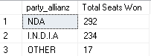

1. Winning candidate's name, their party name, total votes, and the margin of victory for a specific state and constituency?

select Winning_Candidate as [candidate],p.Party,party_allianz ,Total_Votes,cr.margin , Constituency_Name, s.state

from constituencywise_results cr

join partywise_results as p on cr.Party_ID = p.Party_ID

join statewise_results sr on sr.Parliament_Constituency =cr.Parliament_Constituency

join states s on sr.State_ID = s.State_ID

WHERE s.State = 'Uttar Pradesh' AND cr.Constituency_Name = 'AMETHI';



1. What is the distribution of EVM votes versus postal votes for candidates in a specific constituency?

select

cd.Candidate,

cd.party,

cd.EVM_Votes,Postal_Votes,

cd.Total_votes,

cr.Constituency_Name

from constituencywise_details cd

join constituencywise_results cr on cr.Constituency_ID = cd.Constituency_ID

where cr.Constituency_Name = 'Mathura'

order by cd.Total_votes desc;

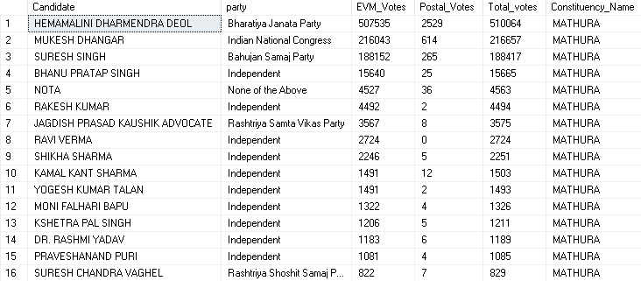

1. **Which parties won the most seats in s State, and how many seats did each party win?**

select pr.party,count(Constituency_ID) as [Seats Won]

from constituencywise_results cr

join statewise_results sr on cr.Parliament_Constituency = sr.Parliament_Constituency

join partywise_results pr on cr.Party_ID = pr.Party_ID

where state = 'Andhra Pradesh'

group by party

Order by [Seats Won] Desc;

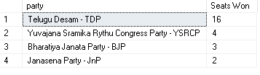

1. **What is the total number of seats won by each party alliance (NDA, I.N.D.I.A, and OTHER) in each state for the India Elections 2024**

select s.State,

Count(Case when party_allianz ='NDA' Then 1 END) as 'NDA',

Count(Case when party_allianz ='I.N.D.I.A' Then 1 END) as 'I.N.D.I.A',

Count(Case when party_allianz ='OTHER' Then 1 END) as 'OTHER'

from statewise_results sr

join constituencywise_results cr on sr.Parliament_Constituency = cr.Parliament_Constituency

join partywise_results pr on cr.Party_ID = pr.Party_ID

join states s on s.State_ID = sr.State_ID

Group by s.State

Order by s.State;

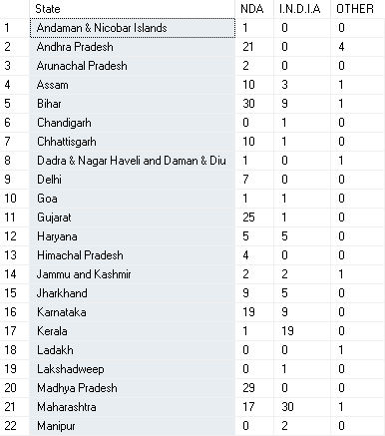

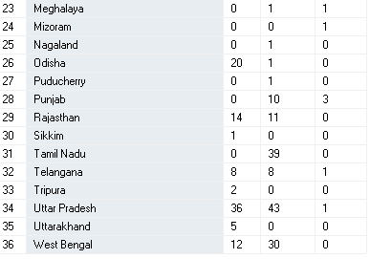

1. **Which candidate received the highest number of EVM votes in each constituency (Top 10)?**

select top(10) cr.Constituency_Name,cd.Candidate,EVM_Votes

from constituencywise_results cr

join constituencywise_details cd on cr.Constituency_ID = cd.Constituency_ID

Order by EVM_Votes desc

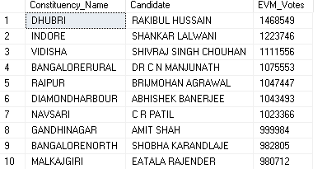

1. **Which candidate won and which candidate was the runner-up in each constituency of State for the 2024 elections?**

select Distinct cr.Constituency_Name,Winning_Candidate, Trailing_Candidate

from constituencywise_details cd

join constituencywise_results cr on cr.Constituency_ID= cd.Constituency_ID

join statewise_results sr on sr.Parliament_Constituency = cr.Parliament_Constituency

join states s on s.State_ID = sr.State_ID

where s.State= 'Maharashtra';

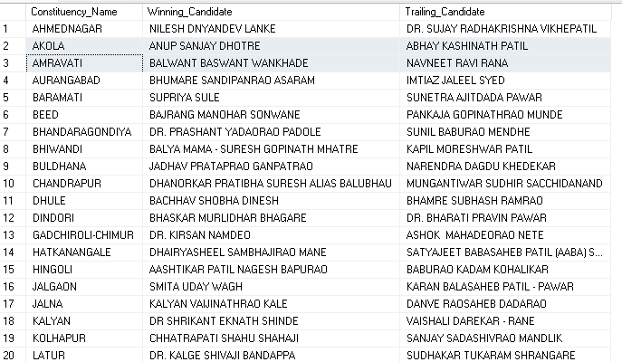

1. **For the state of Maharashtra, what are the total number of seats, total number of candidates, total number of parties, total votes (including EVM and postal), and the breakdown of EVM and postal votes?**

select

count(distinct cd.Constituency_ID) as [Total Seats],

count(distinct Candidate) as [Total Candidates],

count(distinct Party_ID) as [Total Parties],

sum(EVM_Votes+Postal_Votes) as [Total Votes],

sum(EVM_Votes) as [EVM Votes],

sum(Postal_Votes) as [Postal Votes]

from constituencywise_details cd

join constituencywise_results cr on cr.Constituency_ID= cd.Constituency_ID

join statewise_results sr on sr.Parliament_Constituency = cr.Parliament_Constituency

join states s on s.State_ID = sr.State_ID

where s.State= 'Maharashtra';

